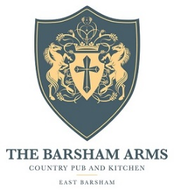

Main Menu

Starters
Soup De Jour, and Homemade Bread V/Vga/gfa £7.95
Black Bomber Rarebit, Asparagus, Honey and Mustard Mayo v £8.95
Duck and Hoisin Wrap, Black Onion Seed Carrots, Cucumber Salad £10.50
Squash and Courgette Flatbread, Garlic and Chive, Crème Fraiche v £8.50
Portwood Asparagus, Pea Pancake, Mirin Emulsion v/gf £9.95

Mains
Pan Fried Sea Bream, Nettle Pesto, Parmentier Potatoes, Portwood Asparagus gf £20.95
Barsham Beef Burger topped with Papworth Bacon and gfa £16.95
Farm House Chedder, Tripple Cooked Chips and Wholegrain Slaw
Slow Cooked Sicilian Beef Ragu, Paperadelle, Toasted Pine Nuts £18.95
Barsham Oaks Battered Haddock, Triple Cooked Chips, Proper Tartare, Pea Puree gfa £17.50
Garlic Mushroom Tacos, Pickled Vegetables, Pressed Leaves v/vga/gf £17.50
8oz Norfolk Ribeye, Chestnut Mushroom Ragu, Butter Milk Onions, gfa £26.95
Triple Cooked Chips
Spiced Norfolk Lamb Koftas, Fennel seed Flatbread, Pickled Vegetables, £21.95
Crème Fraiche, baby leaves
Pea and Asparagus Risotto, Labneh, Garlic v/vga/gf £17.50

gf-gluten free gfa-gluten free adaptable V-vegetarian Va-Vegetarian adaptable Vg-vegan Vga-vegan adaptable

