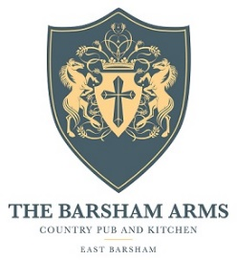

Lunch Menu

Soup De Jour, Homemade Bread v/vga/gfa £7.95
Spiced Lamb Kofte, Pickled Vegetables, Fennel seed Flat Bread £14.95
Soy, Mirin & Ginger Flat Iron Steak, Steamed Bao Bun, Agro Dulce Peppers £14.95
Duck and Hoisin wrap, Black Onion Seed Carrots, Cucumber Salad gfa £13.95
Spiced Squash and Courgette Flat Bread, Garlic and Olive Crème Fraich v £10.95
Pan Fried sea Bream, Nettle Pesto, Parmentier Potatoes, Port Wood Asparagus gf £20.95
8oz Norfolk Ribeye, Chestnut Mushroom Ragu, Butter Milk Onions, gfa £26.95
Triple Cooked Chips
Slow Cooked Sicillian Beef Ragu, Paperadelle, Toasted Pine Nuts £18.95
Barsham Beef Burger, Topped with Bacon and gfa £16.95
Farm House Chedder, Triple Cooked Chips, slaw
Barsham Ale Battered Haddock, Tripple Cooked Chips, gfa £17.50
Homemade Tartare, Pea Puree
Garlic Mushroom Tacos, Pickled Vegetables and Dressed Leaves v/vga/gf £17.50

gf-gluten free gfa-gluten free adaptable V-vegetarian Va-Vegetarian adaptable Vg-vegan Vga-vegan adaptable

