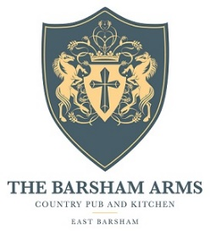

Starters
Homemade bread, cold pressed rapeseed oil V/Vga £5.95
Crispy chicken mousse, king oyster mushroom, kimchi gf £8.95
Seared pigeon breast, apple, truffle, buttermilk, shallot gf £9.95
Soup de jour, crusty bread V/gfa £7.50

Mains
Beef short rib, yorkshire pudding, Norfolk veg and all the trimmings gfa £20.95
Roast British blue beef, yorkshire pudding, Norfolk veg and all the trimmings gfa £16.00
Roast South Creake pork, yorkshire pudding, Norfolk veg and all the trimmings gfa £16.00
Chestnut mushroom roast, yuorkshire pudding, norfolk veg
and all the trimmings V/Vga/gfa £14.00
spiced chicken breast, flat bread, pomegranate, red onion salsa, lime yoghurt £17.95
crispy confit duck leg, chilli and ginger noodles, carrot, winter greens gfa £18.95
roasted pumpkin and tomato gnocchi, garlic crust V £14.95
Barsham ale battered fish, triple cooked chips, crushed peas gfa £16.95

Sides V/gfa £3.50
Triple cooked chips House salad
Buttered new potatoes Mushroom ragout

gf-gluten free gfa-gluten free adaptable V-vegetarian Va-Vegetarian adaptable Vg-vegan Vga-vegan adaptable

