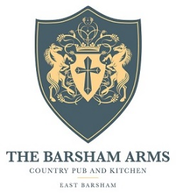

Starters
Homemade bread, cold pressed rapeseed oil V/Vga £5.95
Crispy chicken mousse, king oyster mushroom, kimchi gf £8.95
Crab and golden close rarebit, samphire, parsley aioli gfa £8.25
Seared pigeon, buttermilk, truffle, apple, shallot gfa £9.95
Soup de jour, crusty bread V/gfa £7.50

Mains
Crispy confit duck leg, ginger and chilli noodles, carrot, autumn greens gfa £18.95
Barsham burger, smoky pulled beef, red pepper relish triple cooked chips, slaw gfa £16.95
Spiced chicken breast, flat bread, lime yoghurt, pomegranate gf £17.95
Barsham ale battered fish, triple cooked chips, tartar and crushed peas gfa £16.95
Sea bream fillet, piquillo sauce, new potatoes, runner beans gf £20.95
Moroccan spiced squash burger, triple cooked chips, slaw V/Vga/gfa £13.50
8oz ribeye, triple cooked chips, mushroom ragout, buttermilk onions gfa £23.95
Roast pumpkin and tomato gnocchi, garlic crumb V £14.95
Slow roasted beef rib, truffled Hassel back potato, anise carrots gf £26.95

Sides V/gfa £3.50
Triple cooked chips Buttermilk onions
French fries Slaw
Anise roasted carrots Braised savoy cabbage
Herb buttered new potatoes House salad

gf-gluten free gfa-gluten free adaptable V-vegetarian Va-Vegetarian adaptable Vg-vegan Vga-vegan adaptable

