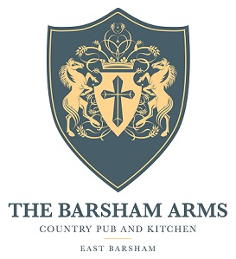

Starters
Homemade bread, cold pressed rapeseed oil V/Vga £4.95
Asparagus, garlic, parsley, Dijon emulsion V/Vga/gfa £8.25
Crab and chive beignet, spring onion, sweet chilli £7.95
Soup de jour, crusty bread V/gfa £7.50

Mains
Crispy confit duck leg, hoisin and sesame noodles, sprouting broccoli £18.95
Sicilian beef ragu, paperadelle, toasted pinenuts gfa £17.95
Barsham burger, smoky bacon, dapple, triple cooked chips, slaw gfa £15.50
Chicken, bacon and avocado salad, garlic croutons gfa £14.95
Barsham ale battered fish, triple cooked chips, tartar and crushed peas gfa £16.95
Rare steak, confit red onion and watercress salad gfa £15.95
Roast celeriac burger, dapple, triple cooked chips, slaw V/Vga/gfa £13.50
8oz ribeye, triple cooked chips, mushroom ragout, buttermilk onions gfa £22.95
Grilled halloumi, spring onion and sweet chilli salad V/gfa £13.95

Sides V/gfa £3.50
triple cooked chips buttermilk onions
French fries slaw
Sprouting broccoli mushroom ragout

gf-gluten free gfa-gluten free adaptable V-vegetarian Va-Vegetarian adaptable Vg-vegan Vga-vegan adaptable

